## PERT Chart Example

Let’s move these concepts from abstraction to reality. To better understand the power of a PERT chart in  
[project management](https://www.projectmanager.com/guides/project-management), let’s make one together. For our PERT chart example, we’ll create a project around building a website. The PERT chart will allow us to visualize our project’s activities and milestones to quickly uncover the critical path.

To begin our PERT example, we’re going to identify all the activities that make up the project and determine the immediate predecessors for each. We’ll list them as shown in the table below.

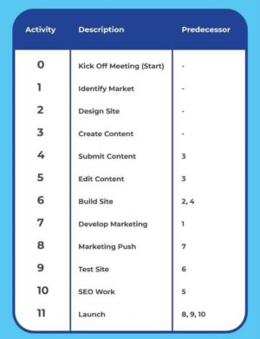

Next, we figure out how long all the activities will take. The amount of time you estimate with the PERT chart formula should be added to the arrows as shown in our PERT chart example. We used weeks as our time unit, but it could be days or months, depending on your project.

Once we have a time estimate for each task, we can draw our PERT diagram. We start with the first node which is the “kick-off meeting” in our example. Then we represent the initial activities with arrows and connect them to their corresponding milestone nodes. We continue the process until we get to the final milestone node of our project.

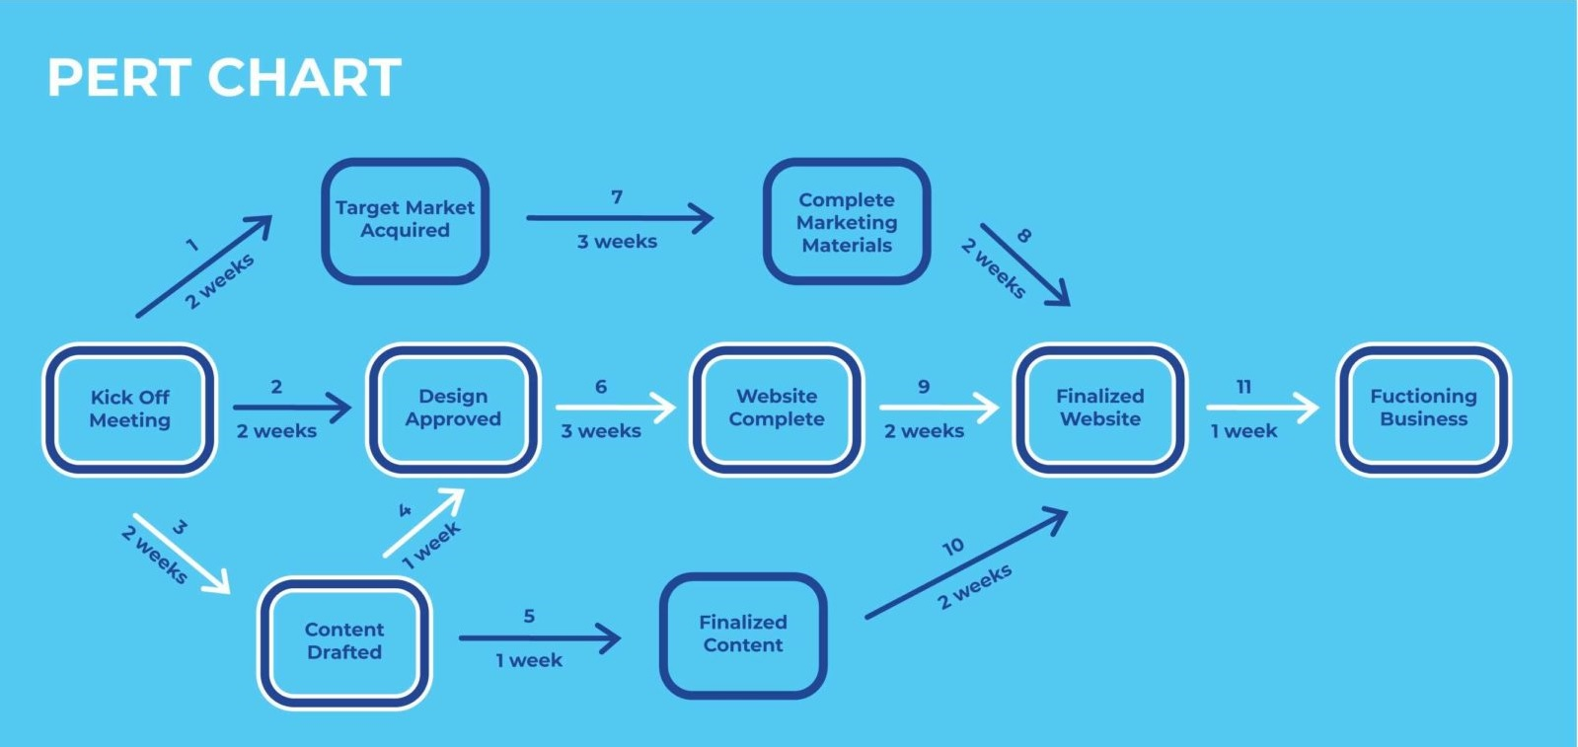

Pro tip: A PERT chart is a great way to help you [estimate simply and more accurately](https://www.projectmanager.com/training/how-to-estimate-simply). Estimates can be overly optimistic or pessimistic, but using a PERT chart will find the most realistic estimate.

Program Evaluation and Review Technique

Q. The following table shows the jobs of a network along their time estimates:

|  |  |  |  |
| --- | --- | --- | --- |
| Activity | Estimated duration(weeks) | | |
| Optimistic | Most likely | pessimistic |
| 1-2 | 1 | 7 | 13 |
| 1-6 | 2 | 5 | 14 |
| 2-3 | 2 | 14 | 26 |
| 2-4 | 2 | 5 | 8 |
| 3-5 | 7 | 10 | 19 |
| 4-5 | 5 | 5 | 17 |
| 6-7 | 5 | 8 | 29 |
| 5-8 | 3 | 3 | 9 |
| 7-8 | 8 | 17 | 32 |

You are required to

1. Draw the project network
2. Find the expected duration
3. Calculate the earliest and latest occurrence for each event.
4. Calculate expected project length.

|  |  |  |  |  |
| --- | --- | --- | --- | --- |
| activity | Opt | Most | Pes | estimated |
| 1-2 | 1 | 7 | 13 | 7 |
| 1-6 | 2 | 5 | 14 | 6 |
| 2-3 | 2 | 14 | 26 | 14 |
| 2-4 | 2 | 5 | 8 | 5 |
| 3-5 | 7 | 10 | 19 | 11 |
| 4-5 | 5 | 5 | 17 | 7 |
| 6-7 | 5 | 8 | 29 | 11 |
| 5-8 | 3 | 3 | 9 | 4 |
| 7-8 | 8 | 17 | 32 | 18 |